**Tamil Nadu**

Tamil Nadu is one of the 28 states of India. Its capital and largest city is Chennai. Tamil Nadu lies in the southernmost part of the Indian subcontinent and is bordered by the union territory of Puducherry and the South Indian states of Kerala, Karnataka, and Andhra Pradesh. It is bounded by the Eastern Ghats on the north, by the Nilgiri Mountains, the Meghamalai Hills, and Kerala on the west, by the Bay of Bengal in the east, by the Gulf of Mannar and the Palk Strait on the southeast, and by the Indian Ocean on the south. The state shares a maritime border with the nation of Sri Lanka.

The region of Tamil Nadu or Tamilakam, in the southeast of modern India, shows evidence of having had continuous human habitation from 15,000 BCE to 10,000 BCE.[1][2] Throughout its history, spanning the early Upper Paleolithic age to modern times, this region has coexisted with various external cultures.

The three ancient Tamil dynasties namely Chera, Chola, and Pandya were of ancient origins. Together they ruled over this land with a unique culture and language, contributing to the growth of some of the oldest extant literature in the world.[citation needed] These three dynasties were in constant struggle with each other vying for hegemony over the land. Invasion by the Kalabhras during the 3rd century disturbed the traditional order of the land, displacing the three ruling kingdoms. These occupiers were overthrown by the resurgence of the Pandyas and the Pallavas, who restored the traditional kingdoms. The Cholas who re-emerged from obscurity in the 9th century by defeating the Pallavas and the Pandyas rose to become a great power and extended their empire over the entire southern peninsula.[citation needed] At its height the Chola empire spanned almost 3,600,000 km² (1,389,968 sq mi) straddling the Bay of Bengal.[citation needed] The Chola navy held sway over the Sri Vijaya kingdom in Southeast Asia.

Tourist place :

|  |  |  |
| --- | --- | --- |
| **Chennai**  [http://www.tamilnadutourism.org/places/places-th/chennai.jpg](http://www.tamilnadutourism.org/places/CitiesTowns/Chennai.aspx) | **Chidambaram**  [http://www.tamilnadutourism.org/places/places-th/chidambaram.jpg](http://www.tamilnadutourism.org/places/CitiesTowns/Chidambaram.aspx) | |
| **Courtallam**  [http://www.tamilnadutourism.org/places/places-th/courtalam.jpg](http://www.tamilnadutourism.org/places/CitiesTowns/Courtallam.aspx) | **Cuddalore**  [http://www.tamilnadutourism.org/places/places-th/cuddalore.jpg](http://www.tamilnadutourism.org/places/CitiesTowns/Cuddalore.aspx) | |
| **Erode**  [http://www.tamilnadutourism.org/places/places-th/erode.jpg](http://www.tamilnadutourism.org/places/CitiesTowns/Erode.aspx) | **Kanchipuram**  [http://www.tamilnadutourism.org/places/places-th/kanchipuram.jpg](http://www.tamilnadutourism.org/places/CitiesTowns/Kanchipuram.aspx) | |
| **Kodaikanal**  [http://www.tamilnadutourism.org/places/places-th/kodaikanal.jpg](http://www.tamilnadutourism.org/places/CitiesTowns/Kodaikkanal.aspx) | **Krishnagiri**  [http://www.tamilnadutourism.org/places/places-th/krishnagiri.jpg](http://www.tamilnadutourism.org/places/CitiesTowns/Krishnagiri.aspx) | |
| **Mamallapuram**  [http://www.tamilnadutourism.org/places/places-th/mamallapuram.jpg](http://www.tamilnadutourism.org/places/CitiesTowns/Mamallapuram.aspx) | **Nagapattinam**  [http://www.tamilnadutourism.org/places/places-th/nagapattinam.jpg](http://www.tamilnadutourism.org/places/CitiesTowns/Nagapattinam.aspx) | |
| **Ooty**  [http://www.tamilnadutourism.org/places/places-th/ooty.jpg](http://www.tamilnadutourism.org/places/CitiesTowns/Ooty.aspx) | **Poompuhar**  [http://www.tamilnadutourism.org/places/places-th/poompuhar.jpg](http://www.tamilnadutourism.org/places/CitiesTowns/Poompuhar.aspx) | |
| **Rameswaram**  [http://www.tamilnadutourism.org/places/places-th/rameswaram.jpg](http://www.tamilnadutourism.org/places/CitiesTowns/Rameshwaram.aspx) | **Salem**  [http://www.tamilnadutourism.org/places/places-th/salem.jpg](http://www.tamilnadutourism.org/places/CitiesTowns/Salem.aspx) | |
| **Thanjavur**  [http://www.tamilnadutourism.org/places/places-th/thanjavur.jpg](http://www.tamilnadutourism.org/places/CitiesTowns/Thanjavur.aspx) | **Theni**  [http://www.tamilnadutourism.org/places/places-th/theni.jpg](http://www.tamilnadutourism.org/places/CitiesTowns/Theni.aspx) | |
| **Thiruvarur**  [http://www.tamilnadutourism.org/places/places-th/thiruvarur.jpg](http://www.tamilnadutourism.org/places/CitiesTowns/Thiruvarur.aspx) | **Tirunelveli**  [http://www.tamilnadutourism.org/places/places-th/tirunelveli.jpg](http://www.tamilnadutourism.org/places/CitiesTowns/Tirunelveli.aspx) | |
| **Tiruchirappalli**  [http://www.tamilnadutourism.org/places/places-th/trichy.jpg](http://www.tamilnadutourism.org/places/CitiesTowns/Trichy.aspx) | **Velankanni**  [http://www.tamilnadutourism.org/places/places-th/velankanni.jpg](http://www.tamilnadutourism.org/places/CitiesTowns/Velankanni.aspx) | |
| **Virudunagar**  [http://www.tamilnadutourism.org/places/places-th/virudunagar.jpg](http://www.tamilnadutourism.org/places/CitiesTowns/Virudunagar.aspx) | **Yercaud**  [http://www.tamilnadutourism.org/places/places-th/yercaud.jpg](http://www.tamilnadutourism.org/places/CitiesTowns/Yercaud.aspx) | |
| **Coimbatore**  [http://www.tamilnadutourism.org/places/places-th/coimbatore.jpg](http://www.tamilnadutourism.org/places/CitiesTowns/Coimbatore.aspx) | |
| **Dharmapuri**  [http://www.tamilnadutourism.org/places/places-th/dharmapuri.jpg](http://www.tamilnadutourism.org/places/CitiesTowns/Dharmapuri.aspx) | |
| **Kanniyakumari**  [http://www.tamilnadutourism.org/places/places-th/kanyakumari.jpg](http://www.tamilnadutourism.org/places/CitiesTowns/Kanniyakumari.aspx) | |
| **Madurai**  [http://www.tamilnadutourism.org/places/places-th/madurai.jpg](http://www.tamilnadutourism.org/places/CitiesTowns/Madurai.aspx) | |
| **Namakkal**  [http://www.tamilnadutourism.org/places/places-th/namakkal.jpg](http://www.tamilnadutourism.org/places/CitiesTowns/Namakkal.aspx) | |
| **Pudukkottai**  [http://www.tamilnadutourism.org/places/places-th/pudukkottai.jpg](http://www.tamilnadutourism.org/places/CitiesTowns/Pudukkottai.aspx) | |
| **Sivagangai**  [http://www.tamilnadutourism.org/places/places-th/sivagangai.jpg](http://www.tamilnadutourism.org/places/CitiesTowns/Sivagangai.aspx) | |
| **Thiruvannamalai**  [http://www.tamilnadutourism.org/places/places-th/thiruvannamalai.jpg](http://www.tamilnadutourism.org/places/CitiesTowns/Tiruvannamalai.aspx) | |
| **Thoothukudi**  [http://www.tamilnadutourism.org/places/places-th/totucorin.jpg](http://www.tamilnadutourism.org/places/CitiesTowns/Thoothukudi.aspx) | |
| **Vellore**  [http://www.tamilnadutourism.org/places/places-th/vellore.jpg](http://www.tamilnadutourism.org/places/CitiesTowns/Vellore.aspx) | |

**Popular Local Dishes of Tamil Nadu**

* 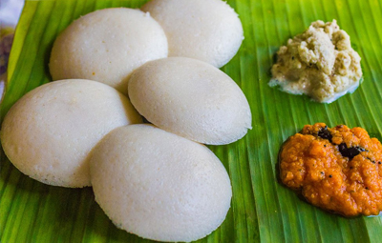

**IDLI**

The most famous dish in Tamilnadu, as well as the whole southern region is Idli. Prepared with a grind mixture of soaked rice and white lentil, Idli is best to eat in the breakfast time.

* 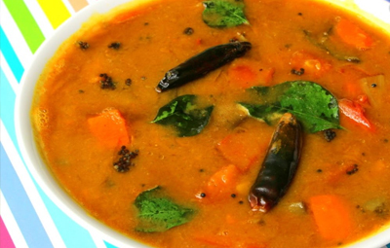

**SAMBAR**

Best to enjoy with almost every main course, Sambar is a kind of South Indian dal (pulse). Yet, the difference is the concocting of various vegetables and spices and the sour taste.

* 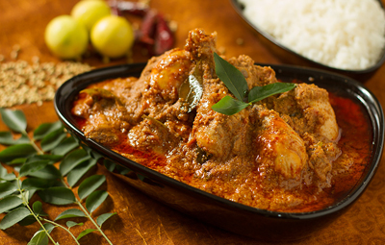

**CHICKEN CHETTINAD**

For all non-veg lovers, one of the ideal dishes in Tamilnadu is Chicken Chettinad. Dipped in the authentic flavours of roasted spices, this dish brings a new taste to your palate.

* 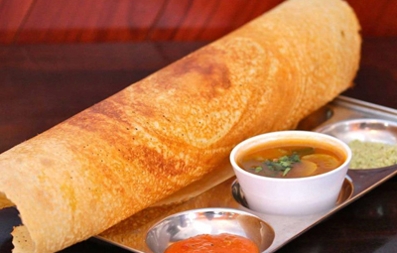

**DOSA**

Dosa is famous preparation in Tamil Nadu. The dish is cooked mildly like an omelette where the mixture is spread over a pan and is served with Sambar and Coconut Chutney.

* 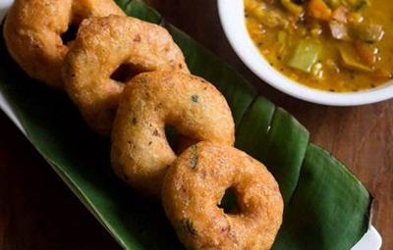

**VADA**

Another complement of Sambhar, Vada is a savoury doughnut-like snack that traces its history in Tamil Nadu and is a prominent breakfast delicacy in the state.

* 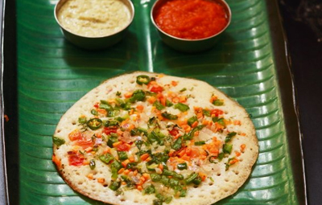

**UTTAPAM**

This delectable dish is very much similar to dosa but what makes it different is the topping of tomatoes, onions, capsicum, and other veggies. Uttapam tastes heavenly good with either spicy tomato or coconut chutney.

* 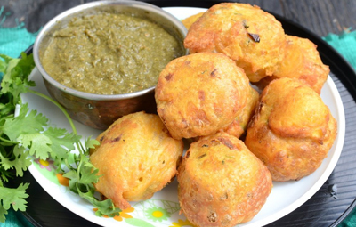

**BANANA BONDA**

Stuffed with banana and deep fried in oil, Bonda is savoury preparation in the state of Tamil Nadu, best to eat at snack time with tea.

* 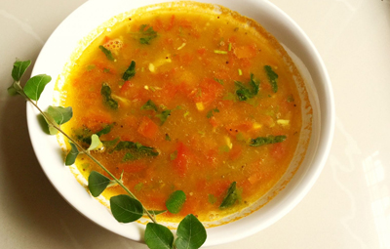

**RASAM**

One of the most common main courses in Tamilnadu, Rasam is a spicy soupy dish prepared with tomatoes, cumin seeds, and pepper. It is also an appetizing dish for a sore throat.

* 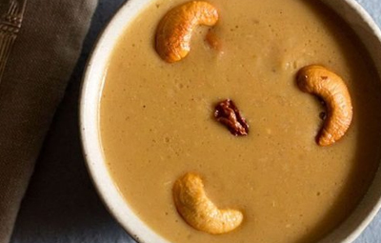

**PAYASAM**

A piquant desert, Payasam is a popular second course in Tamilnadu. This dish is prepared by roasting moong dal and cooking it in a pressure cooker along with adding jaggery syrup and dry fruits.

* 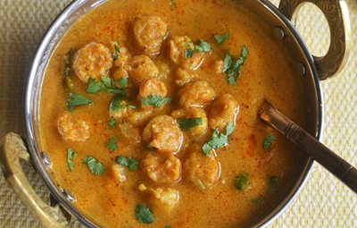

**PRAWNS KUZHAMBU**

A perfect epitome of South Indian cuisine is Prawns Kuzhambu, serving as a gastronomic delight in Tamilnadu. The prawns are marinated in masala which gives it a strong tangy tast

10 Things Tamil Nadu is Famous For

India worthwhile and memorable. 1. Meenakshi Amman Temple, Madurai Meenakshi Amman Temple is one of the most popular tourist attractions of Tamil Nadu. The temple architecture in South India is as relevant as that of Taj Mahal in North India. The temple complex is spread across six hectares of land with 12 gopurams that stand tall. 2. Ambur Dum Biriyani from Vellore Vellore district in Tamil Nadu is known among the food lovers. The Ambur Chicken biriyani, one of the special South Indian biriyanis takes its origin at Ambur, a small town in Vellore district of Tamil Nadu. Photo Courtesy: Umesh Tongbra 3. Kanchipuram for the Silks Kanchipuram sari, or Kanjivaram sari, is a sari that's traditionally woven by weavers from Kanchipuram. These saris are known for their intricate designs, colours and the materials used like zari and golden thread. Photo Courtesy: Simply CVR 4. Chettinad Cuisine from Karaikudi Chettinad cuisine is also known as Karaikudi cuisine. The cuisine is a pride of karaikudi, a town in Sivagangai district of Tamil Nadu. The dishes are prepared using several spices and herbs. This cuisine is referred to as 'Achi Samayal' by the locals. The cooking style employed also makes Chettinad cuisine unique among other cuisines. Photo Courtesy: Yashima With 10 Days Hair Oil You Need Not Worry About Hair Loss 10 Days Hair Oil Vostro 14 3000 series featuring an FHD display with a 2-sided narrow… Dell Exclusive deals for business visionaries. Dell 5. Sunrise in Kanyakumari If you haven't yet experienced how skies change shades in moments, visit Kanyakumari and watch the sunrise. The southernmost tip of India located in Tamil Nadu, Kanyakumari is aptly called as the Virgin Beauty. From light shades of orange to deeper fierce and brighter shades that appear and disappear on the skies is a sight to behold. 6. A stroll at Marina Beach Marina Beach in Chennai is the world's second longest beach and India's longest urban beach. 13Km of serene and fierce waves awaits you. Sinking your feet in the sands as you walk by is truly a refreshing experience to witness at Chennai. 7. The dolls and paintings in Thanjavur The dolls known as 'thalayatti bommai' and the famous Thanjavur paintings make the city distinct among the other cities of Tamil Nadu. Photo Courtesy: Booradleyp 8. Pamban Bridge in Rameshwaram The Pamban Bridge that's 2.3 km long, is one of the places that are not to be missed in Tamil Nadu. The bridge is the second longest sea bridge in India. Pamban bridge connects Rameshwaram to the rest of Tamil Nadu. 9. Kallanai Dam in Trichy Kallanai Dam in Trichy is one of the oldest dams in the world, which is being used till date. Constructed over river Cauvery, the dam is 329m long and 20m wide. The dam is one of the famous things Tamil Nadu is known for. Photo Courtesy: Thangaraj Kumaravel 10. Fire Crackers from Sivakasi Even the small kids in Tamil Nadu would be familiar with Sivakasi fire crackers. The town is popular for its firecrackers and match factories. During festive seasons, people flock in to get authentic and cheap fire crackers from the place.

# **Himachal Pradesh**

Himachal Pradesh "snow-laden province") is a state in the northern part of India. Situated in the Western Himalayas, it is one of the eleven mountain states and is characterized by an extreme landscape featuring several peaks and extensive river systems. Himachal Pradesh shares borders with the Union territories of Jammu and Kashmir and Ladakh to the north, and the states of Punjab to the west, Haryana to the southwest, and Uttarakhand and Uttar Pradesh to the south. The state shares a border to tTribes such as the Koli, Hali, Dagi, Dhaugri, Dasa, Khasa, Kanaura, and Kirat inhabited the region from the prehistoric era.[14] The foothills of the modern state of Himachal Pradesh were inhabited by people from the Indus valley civilisation which flourished between 2250 and 1750 B.C.[15] The Kols and Mundas are believed to be the original inhabitants to the hills of present-day Himachal Pradesh followed by the Bhotas and Kiratas.

During the Vedic period, several small republics known as Janapada existed which were later conquered by the Gupta Empire. After a brief period of supremacy by King Harshavardhana, the region was divided into several local powers headed by chieftains, including some Rajputs principalities. These kingdoms enjoyed a large degree of independence and were invaded by Delhi Sultanate a number of times.[15] Mahmud Ghaznavi conquered Kangra at the beginning of the 11th century. Timur and Sikander Lodi also marched through the lower hills of the state and captured a number of forts and fought many battles.[15] Several hill states acknowledged Mughal suzerainty and paid regular tribute to the Mughals.he east with the Tibet Autonomous Region in China.

top Himachal Pradesh places to visit. You'll find everything from pottery to paragliding there!

**01**of 10

## Shimla

RBB/Getty Images

Shimla used to be the summer capital of the British Raj when they ruled India. Now it's the state capital of Himachal Pradesh. The town sprawls along a mountain ridge, enveloped in oak, pine and rhododendron forests. It's quite famous for its colonial-style buildings and historic railway. Some would stay it's overdeveloped and crowded these days. However, it still has charm. The old Christ Church, with its beautiful stained glass windows, is one of Shimla's most prominent landmarks. Another is the Viceregal Lodge on Observatory Hill. These can be seen on a [historic walking tour of Shimla.](https://www.tripsavvy.com/historical-places-in-shimla-on-walking-tour-1539328) There are plenty of adventure sports and short hikes on offer in the vicinity as well.

* [**Travel on the Toy Train to Shimla**](https://www.tripsavvy.com/kalka-shimla-railway-toy-train-guide-1539635)
* [**Sunnymead Bed & Breakfast: A Gastronomic Experience in Shimla**](https://www.tripsavvy.com/sunnymead-bed-and-breakfast-1539332)

**02**of 10

## Manali

Andrew Bain/Getty Images

Manali, with its soothing backdrop of the Himalayas, offers a blend of tranquility and adventure that makes it one of northern India's most popular destinations. You can do as little or as much as you want there. Located in the Kullu Valley, it's a magical place bordered by heady pine forest and the raging Beas River, which give it a special energy.

* [**Manali Essential Travel Guide**](https://www.tripsavvy.com/kullu-manali-essential-travel-guide-1539784)
* [**Top 10 Places to Visit in Manali**](https://www.tripsavvy.com/places-to-visit-in-and-around-manali-1539509)
* [**6 Best Luxury Resorts in Manali**](https://www.tripsavvy.com/best-luxury-resorts-in-manali-1539389)
* [**10 Cheap Guesthouses & Budget Hotels in Old Manali**](https://www.tripsavvy.com/cheap-guesthouses-budget-hotels-in-old-manali-1539385)

**03**of 10

## Dharamsala and MacLeod Ganj

Richard I'Anson/Getty Images

Nestled a short distance from each other in the Kangra Valley, the towns of Dharamsala and MacLeod Ganj are home to the exiled Tibetan Government. The Dalai Lama resides in Dharamsala, and many Tibetans have followed him there. You can expect to find a strong Tibetan influence in the area, with culture being the main attraction.

People flock to Dharamsala and MacLeod Ganj to undertake Buddhist meditation and philosophy courses, Tibetan cooking classes, Tibetan language courses, and to receive alternative therapies. Volunteer work is another popular pastime. Those interested in sightseeing will find some fascinating museums, temples, gompas, and monasteries. [Tsuglagkhang Complex](https://www.tripsavvy.com/tsuglagkhang-home-of-the-dalai-lama-1458245), the official residence of the Dalai Lama, is a highlight.

**04**of 10

## Andretta

Ekabhishek/Flickr/CC BY-SA 3.0

If you're interested in pottery or art, don't miss quaint Andretta village, a 20 minute drive from Palampur in the Kangra District. It can be visited on a day trip from Dharamsala. Otherwise, stay at the delightful Mirage Heritage Homestay.

The village is said to have been established in the 1920s by Irish playwright Norah Richards, who lived there during the Partition and is credited with the rise of Punjabi theater. Later, noted potter Gurucharan Singh (who started Delhi Blue Pottery), and painter Sobha Singh (who was known for his Sikh religious paintings), settled there. The Sobha Singh Art Gallery, housed in the building where he lived, showcases his paintings and personal belongings. The mud-plastered cottage belonging to Norah Richards can also be visited.

Andretta Pottery and Craft Society, a pottery production center, offers three month [pottery classes for serious students](http://www.andrettapottery.com/Pottery.html). Alternatively, you can try your hand at the pottery wheel and get a casual lesson. The Society apparently sells its rangoli-patterned earthenware to FabIndia in Delhi.

Continue to 5 of 10 below.

**05**of 10

## Bir-Billing

Jitendra Singh/Getty Images

Go past the turnoff to Andretta from Palampur and you'll reach one of the world's best paragliding destinations at the twin towns of Bir and Billing. The 2015 Paragliding World Cup was held there, for the first time in India, [in October](https://www.tripsavvy.com/october-india-festivals-and-events-guide-1539301) 2015. The peak paragliding season runs from March to May and October to November. [Billing Valley Adventures](http://www.billingvalley.com/) and [Billing Adventures of Himachal](http://www.billingadventures.com/) offer paragliding, trekking, and camping. Other attractions are tea gardens and monasteries. Serene [Palpung Sherabling Monastery](https://www.tripsavvy.com/buddhist-monasteries-in-india-1539714) offers periodic courses in Buddhist meditation and philosophy. Deer Park Institute offers accommodations along with courses on Buddhist and Indian philosophy. Don't miss visiting the groovy 4Tables Project cafe and art gallery. They now rent out gorgeous [rooms](http://www.the4roomshotel.com/) too! Guided walks in the area can be arranged.

* [**Top 10 Adventure Travel Activities in India**](https://www.tripsavvy.com/popular-adventure-travel-activities-in-india-1539126)

**06**of 10

## Spiti

Quynh Anh Nguyen/Getty Images

Rudyard Kipling described Spiti as a world within a world. This remote, high altitude area of Himachal Pradesh is tucked away against the border of Ladakh and Tibet. It's only been open to foreign tourists since 1991, and still remains relatively unexplored. Part of this is due to Spiti being barren alpine desert that's covered in heavy snow for a high proportion of the year.

Getting to Spiti involves a long drive, most popularly from Manali. The constantly evolving scenery is unforgettable and well worth the journey though.

* [**Essential Spiti Travel Planner**](https://www.tripsavvy.com/spiti-india-travel-planner-1539333)
* [**Manali to Spiti Photo Gallery**](https://www.tripsavvy.com/road-from-manali-to-kaza-in-spiti-photos-4063993)
* [**Photo Gallery of the Spiti Valley**](https://www.tripsavvy.com/india-spiti-valley-pictures-4064000)

**07**of 10

## Great Himalayan National Park

Sandeep Somasekharan/Flickr/CC BY-NC ND

The Great Himalayan National Park, in the Kullu District of Himachal Pradesh, became a UNESCO World Heritage Site in 2014. The park has four valleys and covers about 900 square kilometers. Its remote, rugged and untamed terrain makes it sought after by trekkers but only the fittest and most adventurous reach deep inside the core area. There are a number of [trekking routes](http://greathimalayannationalpark.com/park-treks/), ranging from three to eight days, with treks between the spectacular Tirthan and Sainj valleys being popular.  In addition, less strenuous day walks exist in the park's Ecozone buffer area, frequented by day trippers. It's possible to go on tours to interact with the villagers and learn about their activities.

Ecotourism company [Sunshine Himalayan Adventures](http://ankitsood.wix.com/sunshinehimalayanadventures) has partnered with Biodiversity Tourism and Community Advancement (a community-based organization, comprised of local villagers) to offer treks and tours. Permits are required for treks. Indians must pay a park entry fee of 50 rupees per day, and foreigners 200 rupees per day. It's free to enter the Ecozone.

[Raju's Cottage](https://www.facebook.com/Rajubhartiguesthouse/), a renowned homestay in Gushaini on the periphery of the park, is an ideal base or stopover. You'll need to book well in advance though!

**08**of 10

## Kasol and the Parvati Valley

Ami Vitale/Getty Images

As the season wanes in Goa, the psychedelic trance scene shifts more than 8,000 feet above sea level into the forest around Kasol, in the Kullu District's Parvati Valley. Festivals take place at Chalal, near Kasol, from late May until October. To get there, walk 30 minutes from Kasol, crossing the cable suspension bridge over the Parvati River and then following the picturesque riverside path to the village. The season runs from late May until October. Two of the biggest events are [Parvati Peaking](https://www.facebook.com/parvatipeaking/" \t "_blank) and [Magica Festival](https://www.facebook.com/Magica-festival-Flower-Power-Parvati-Project-408627622526679/" \t "_blank).

Continue to 9 of 10 below.

**09**of 10

## Dalhousie

RBB/Getty Images

Dalhousie is refreshingly less crowded than Shimla and Manali, and the surrounding Chamba Valley is a lesser-explored area of Himachal Pradesh. If you're after spectacular views, then Dalhousie is the place to find them. Spread over five hills at foot of the Dhauladhar mountain range, the town gets its name from founder Lord Dalhousie and bares the distinct stamp of the British Raj. Its hotels are particularly reminiscent of that era.

Kalatope Wildlife Sanctuary is located a short drive away from Dalhousie. It's possible to walk through the sanctuary but a permit is necessary for a vehicle. Those who dare to venture further into the Chamba Valley will discover fascinating ancient folklore, temples, and tribes.

**10**of 10

## Himalayan Golden Triangle (Thanedhar, Sangla and Sojha)

Cultura RM/Dmitry Rukhlenko/Getty Images

This off-beat circuit, actively promoted by [Banjara Camps](http://www.banjaracamps.com/" \t "_blank), attracts outdoor enthusiasts who want to enjoy nature away from touristy areas. It starts in the heart of Himachal Pradesh's apple country, in Thanedhar (around two hours from Shimla). The Sangla Valley is located 9,000 feet above sea level in Kinnaur District, close to the Tibetan border, and offers trout fishing and trekking (including glacier trekking in March and April). You can also visit Chitkul village, the last village on the old Indo-Tibetan trade route. Sojha links the Kullu and Shimla districts, and provides more opportunities to venture into the wild mountainous countryside.

# **12 Delicious and Traditional Food of Himachal Pradesh!**

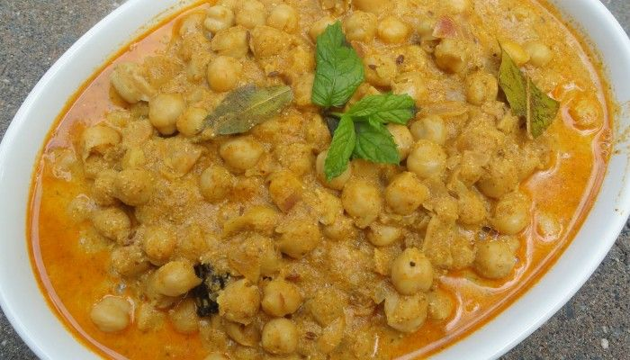

The snow-clad mountains, the lush green valleys, the freshness in the air, tranquillity in the environment, these are few things that describe Himachal Pradesh at its best. And, there you go missing a big surprise that Himachal has got for its loyal travellers. The scrumptious food. From the road vendors to the authentic cafes and restaurant, the Himachali people will pour their heart out in their dishes. So, on your next trip to this beautiful state do not miss out on some of the mouth-water dishes that they have to offer you.

## 1. Madra



Chana Madra [(Source)](http://viralstories.in/13-traditional-dishes-himachal-must-definitely-try/)

**Where to find?** Chamba and Kangra  
Madra is originally a delicacy that belongs to the Chamba district of Himachal Pradesh. The dish mainly consists of the soaked chickpeas (chana) or vegetables. Cooked well in the oil and various spices such as cloves, cinnamon, cardamoms, cumin, coriander powder and turmeric powder enhance the taste of this dish. Madra is one of the dishes that represents the food culture of Himachal Pradesh. Every restaurant, every occasion, and the festival will have Madra offered to you with utmost love.

## 2. Dhaam

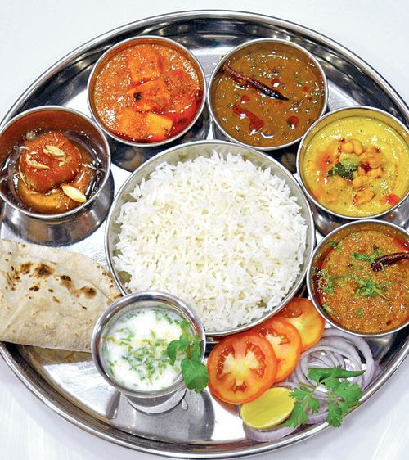

Dham[(Source)](https://in.pinterest.com/pin/145100419217428645/" \t "_blank)

**Where to find?** Manali and Chamba  
Dhaam is a complete food that along with a great taste promises a healthy dose of nutrients. The dish includes dal, rajma, rice, curd, boor ki Kadi and is very well complemented with gur (jaggery). Dhaam is a plate full of delicious delicacies that are a must-serve on the occasions and festivals. The distinctive feature about this dish is that it is prepared by special chefs known as ‘botis’. To grab the best taste of Dhaam you must visit Himachal during festivals.

## 3. Tudkiya Bhath

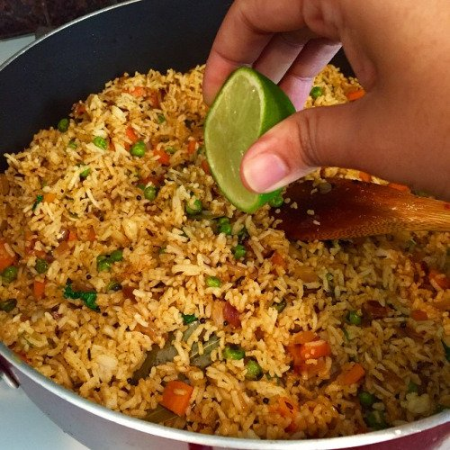

Tudkiya Bhat[(Source)](http://viralstories.in/13-traditional-dishes-himachal-must-definitely-try/" \t "_blank)

**Where to find?** Chamba  
Tudkiya Bhath is the authentic pulao of Himachal Pradesh that pahadi people cook in their own very style. What’s unique? The dish is not only cooked with Indian spices but an extra add up to the lentils, potatoes and yoghurt along with onion, tomatoes, garlic, cinnamon, cardamom provides this dish such a great taste that will make you want it again and again. For the best taste, Tudkiya Bath is complemented with mash dal and few drops of lime juice.

## 4. Bhey or Spicy Lotus stems

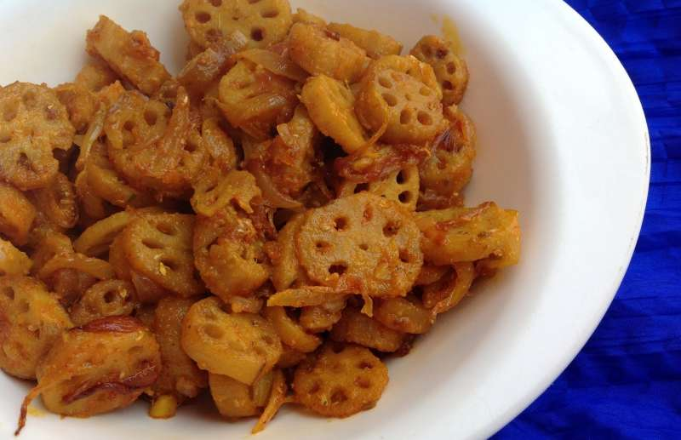

Bhey [(Source)](http://www.cookingwithsapana.com/2014/04/spicy-bhey-lotus-stem-curry.html)

**Where to find?** All over Himachal

A famous dish of Himachal Pradesh that is fondly eaten in the households of the Himachali people. Bhey is a delicious dish which is prepared with the lotus stems. Thinly sliced lotus stems are then cooked in the ginger-garlic, onions and gram flour which adds the unique and great taste to the dish.

## 5. Chha Gosht

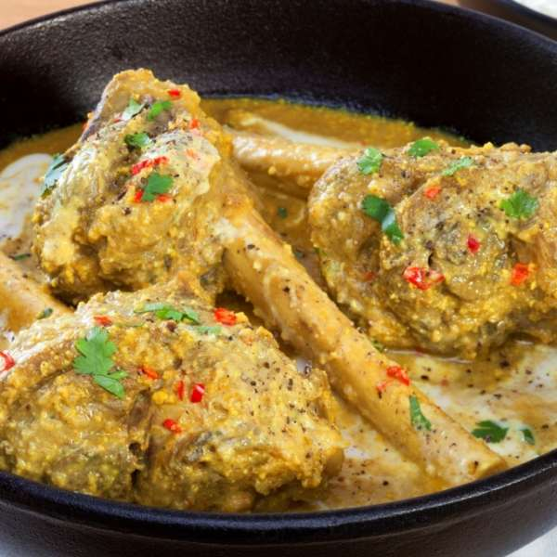

Chha Gosht [(Source)](http://www.whatshot.in/delhi-ncr/the-unexplored-cuisine-of-himachal-c-219)

**Where to find?** Chamba  
If you are a hard-core vegetarian then nothing can serve you better than Chha Gosht. A typical Himachal delicacy, Chha Gosht is a scrumptious dish prepared with the marinated lamb which is further cooked in the gravy of gram flour and yogurt.The taste of this dish is highly enhanced when it is well cooked in the Indian spices such as cardamom, red chili powder, coriander powder, bay leaf, asafoetida and ginger-garlic paste.

## 6. Siddu

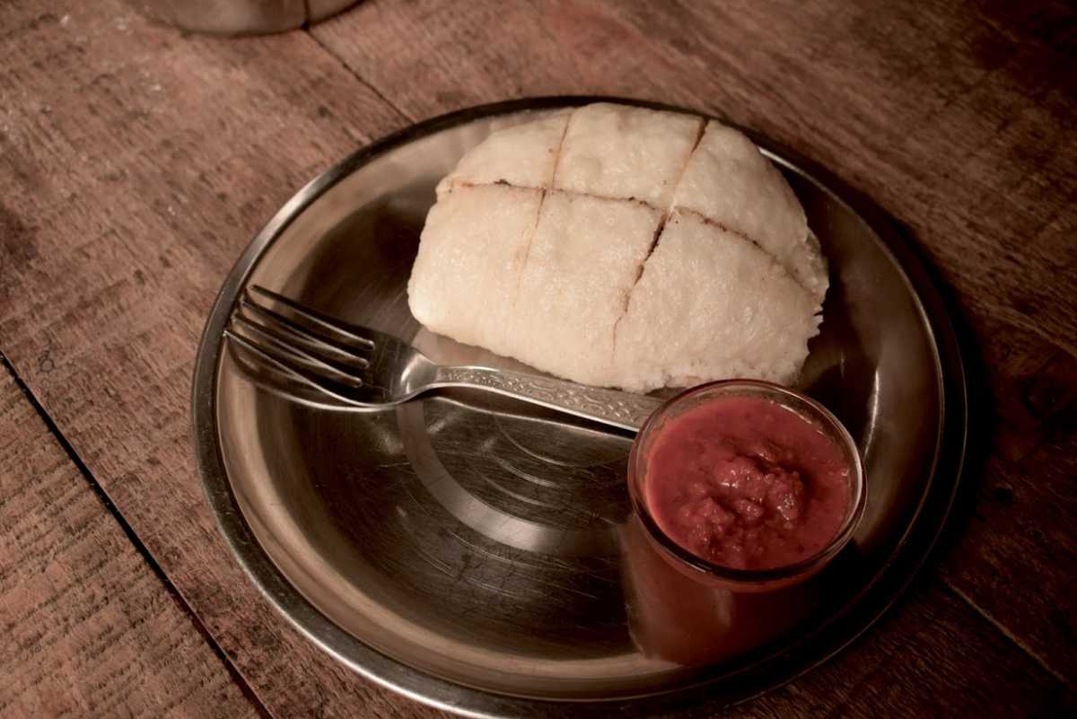  
Made from wheat flour, Sidu is a local side- dish of Himachal Pradesh which greatly complements the main course of mutton or some vegetables. The preparation of Sidu is difficult and time-consuming, but for the taste that it renders, every minute of preparation is worth it. The wheat flour is kept for 4-5 hours for the yeast to settle down. Later, the dough is filled with fat and put on the direct flame to get the half-cooked dough. This partly cooked dough is then steamed to keep the taste and nutrients of the ingredients intact. Sidu can easily be found in the local restaurants of Himachal Pradesh to give tourists a flavour of Himachali cuisine.

## 7. Babru

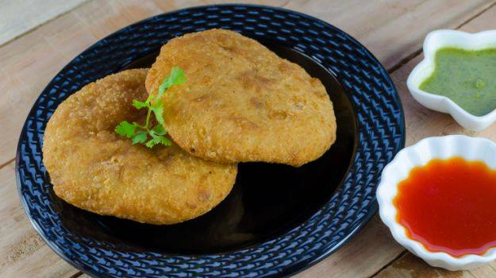

Babru[(Source)](http://www.vegfoodrecipes.in/all/recipe/babru/" \t "_blank)

**Where to find?** Shimla  
Himachal have added a unique twist to popular Kachoris of North India. Babru is a flat bread which is prepared with the stuffing of black gram paste which is added to the kneaded dough. The crisp and the scrumptious taste that this dish has to offer will make you forget the conventional Kachoris of North India. Babru is best enjoyed with Tamarind chutney and it also complements the famous Chana Madra of Himachal cuisine.

## 8. Aktori

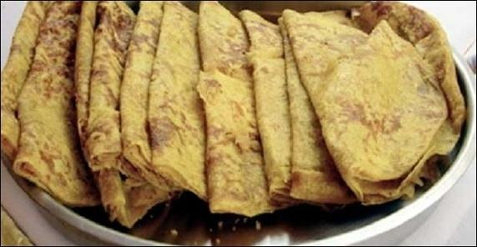

Aktori [(Source)](https://www.quora.com/What-is-the-best-food-of-Himachal-pradesh)

**Where to find?** Lahaul- Spiti  
Aktori is a festive dish which is very much enjoyed by the people of Himachal Pradesh during their festive time. Aktori is prepared in the form of a cake or pancake made with the buckwheat leaves which is further cooked in the wheat flour. Although, the dish originates in Spiti Valley but it is frequently prepared and fondly eaten all over Himachal Pradesh.

## 9. Kullu Trout fish

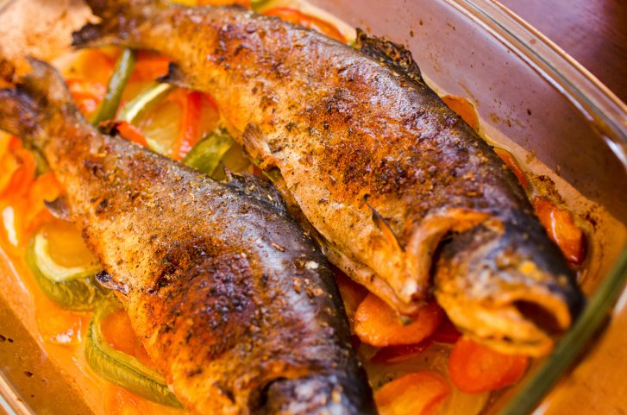

Kullu Trout Fish [(Source)](http://food.ndtv.com/recipe-kullu-trout-554227)

**Where to Find?** Kullu  
Himachal Pradesh promises a great number of non-vegetarian delicacies. Kullu trout is a famous dish of Kullu region which is prepared with trout fish. The marinated fish is cooked in the minimal spices to keep the nutrients and the original taste of Trout intact. The dish is best coupled with the number of boiled vegetables, and hence it remains one of the healthiest delicacies of Himachal Pradesh.

## 10. The Tibetan dishes

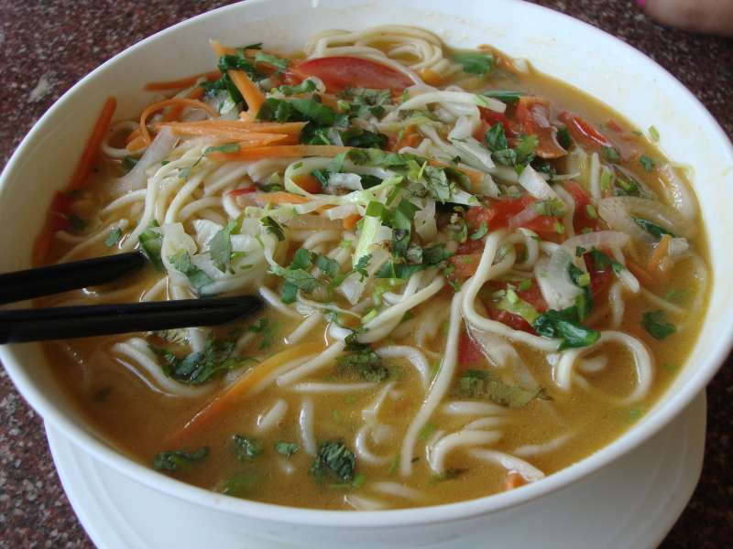

Thupka [(Source)](http://thebrownscooter.com/recipe-of-thukpa/)

The food talk of Himachal Pradesh cannot be completed without including the Tibetan cuisines. Being an important Tibetan colony, the regional food of Himachal Pradesh is highly inspired by the Tibetan culture. The best of which can be found in Mcleodganj and Dharamshala. Momos remains the all the time favorites of Himachali people that. Apart from that, Thukpa, Tingmo , LuchiPoti, Thentuk, Naizha Cake are some of the dishes that can be enjoyed in the kiosks of Himachal Pradesh.

## 11. Mittha

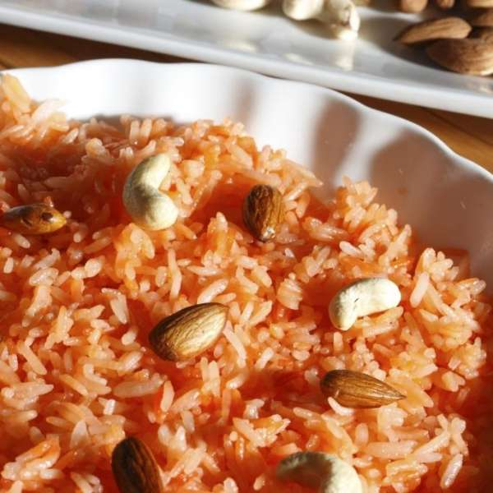

[Source](https://whatshot.in/delhi-ncr/the-unexplored-cuisine-of-himachal-c-219)

Mittha is the sweet dish of Himachal Pradesh prepared on special occasions. It has sweetened rice mixed with dry fruits and raisins.

## 12. Kaale Channe ka Khatta

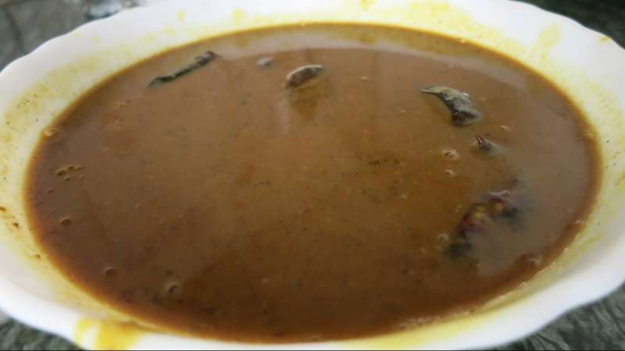

Source: Youtube

Where to find? Kangra

It is a traditional Pahari Dish which is sour in taste and is usually served with rice. This dish is usually served with Madra.

Now, you know what not to miss when in the region of Himachal Pradesh. These delicious delicacies just add an extra perk to your travelling experience. And isn’t traveling about experiencing the culture?

# Things to Buy from Himachal Pradesh

After a fun-filled holiday, take back Himachal Pradesh home by picking some of the best souvenirs that keep reminding of the serenity of this tourist destination. Shopping in Himachal Pradesh will give you an exciting experience where you can explore and even buy gifts for your loved ones. The state has something or the other for the tourists of all interest. Be it, paintings, handicrafts, woodwork, metalwork, the famous shawls, Himachali caps and more, you are going to find it in all the tourist places of Himachal Pradesh. While shopping in Himachal Pradesh, tourist can pick from a wide variety of things. Be the beautiful shawls of Kullu or the Rumals (handkerchief) of Chamba; it is impossible to visit the Himachal Pradesh and return without buying anything. As the metal jewellery of the state is high in demand worldwide, tourists can head to Kullu and [Chamba](https://www.tourmyindia.com/states/himachal/chamba.html" \t "_blank).

Also, for those with the fond of Tibetan jewellery, can buy from the tiny shops of Manali, [Shimla](https://www.tourmyindia.com/states/himachal/shimla.html), [Dharamshala](https://www.tourmyindia.com/states/himachal/dharamshala.html" \t "_blank) that present a treasure trove of anklets, neckpieces, amulets, rings and more. Tourist can even shop for the delightful Chamba and Kangra paintings with small details of the romantic tales of Lord Krishna and his beloved Radha from the Hindu mythology. For tourists [travelling to Kinnaur](https://www.tourmyindia.com/states/himachal/kinnaur.html), can carry back home the colourful caps. Also, the intricately designed Kinnauri Joothis are famous and can be added to the shopping bag. The woodwork of Himachal Pradesh will give you the opportunity to buy products like trays, sculpture, sticks, utensils, toys and other household products.

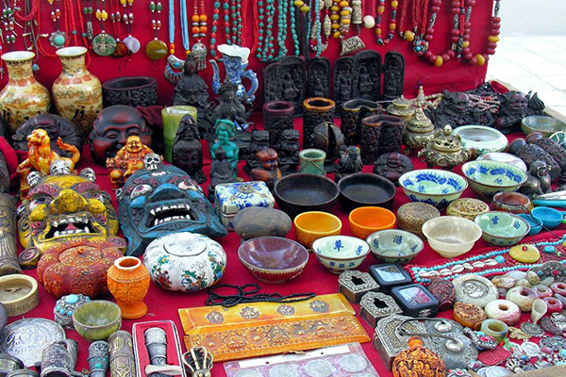

Apart from this, Wall Hangings, Tibetan Thangkas, Books on Travel, Prayer Wheels are few other things one can buy when visiting Himachal Pradesh. So plan a trip to Himachal Pradesh, go to the famous shopping destinations and take delight in amazing shopping.

ASSAM

Assam (/æsˈsæm, əˈsæm/,[10][11] Assamese: [ɔxɔm] (About this soundlisten)) is a state in northeastern India, situated south of the eastern Himalayas along the Brahmaputra and Barak River valleys. Assam covers an area of 78,438 km2 (30,285 sq mi). The state is bordered by Bhutan and Arunachal Pradesh to the north; Nagaland and Manipur to the east; Meghalaya, Tripura, Mizoram and The history of Assam is the history of a confluence of people from the east, west, south and the north; the confluence of the Tibeto-Burman (Sino-Tibetan), Indo-Aryan and Austroasiatic cultures. Although invaded over the centuries, it was never a vassal or a colony to an external power until the third Burmese invasion in 1821, and, subsequently, the British ingress into Assam in 1824 during the First Anglo-Burmese War.

The Assamese history has been derived from multiple sources. The Ahom kingdom of medieval Assam maintained chronicles, called Buranjis, written in the Ahom and the Assamese languages. History of ancient Assam comes from a corpus of Kamarupa inscriptions on rock, copper plates, clay; royal grants, etc. that the Kamarupa kings issued during their reign. Protohistory has been reconstructed from folklore: epics like Mahabharata, and two medieval texts compiled in the Assam region—the Kalika Purana and the Yogini Tantra.Bangladesh to the south; and West Bengal to the west via the Siliguri Corridor, a 22 kilometres (14 mi) wide strip of land that connects the state to the rest of India. It is also one of the world's most populous subdivisions. Assamese is the official and most common language, followed by Bengali, the second most common.

Tourist Hotspots

A rhino in Kaziranga National Park. The park is home to two-thirds of the world's great one-horned rhinoceroses.

Elephant safari in Kaziranga National Park

A scenic tea estate of Assam

For the purposes of tourism there are wildlife reserves like the Kaziranga National Park, Manas National Park, Pobitora Wildlife Sanctuary, Nameri National Park, Dibru-Saikhowa National Park etc. It has a rich cultural heritage going back to the Ahom Dynasty which governed the region for many centuries before the British occupation.

Notable tourist destinations are listed below:[1]

Guwahati

Main article: Guwahati

Kamakhya Temple

One of the key urban centres of Assam and the biggest city in North-East India, this serves as the major gateway to the whole region. The major tourist spots of Guwahati are Kamakhya Temple, River Cruise on the river Brahmaputra, Shankardev Kalakshetra, Umananda Temple, Assam State Zoo, Shilpagram etc. Chandubi Lake, Sonapur, Madan Kamdev, Chandrapur and Pobitora Wildlife Sanctuary are other famous spots outskirts the city .While visiting Madan Kamdev Tourists also visit the ancient temple Gopeswar Mandir situated in the village Deuduar.

Majuli

Main article: Majuli

A view of Majuli

The largest freshwater island[2] in South Asia on the Brahmaputra River. Majuli is famous for its Vaishnavite Satras such as Kamalabari Satra, Dakhinpat Satra, Garamurh Satra, Auniati Satra, Bengenaati Satra and Samaguri Satra.

Kaziranga National Park

Main article: Kaziranga National Park

This protected area is a UNESCO World Heritage Site and serves as one of the last remaining habitat of the Great Indian One-horned Rhinoceros. Also check out Manas National Park and Orang National Park.[3][4]

Jatinga

Main article: Jatinga

This village is famous for mysterious suicides of the birds, located in Dima Hasao.

Sonitpur

Main article: Sonitpur district

View of Nameri National Park of Sonitpur District.

Protected areas to see in the district are Nameri National Park, Bura Chapori Wildlife Sanctuary, Sonai Rupai Wildlife Sanctuary and a part of Orang National Park. Bhalukpong is also an important tourist place. Tezpur is a small town steeped in history and culture. Some of these are Agnigarh, Mahabhairav Temple, Chitralekha Udyan, Bamuni Hills, Usha Pahar etc. Biswanath Chariali town is 75 km away from Tezpur, is famous for the Biswanath Ghat, also called popularly as "Gupta Kashi".

Jorhat

Main article: Jorhat district

Situated at 318 km east from Guwahati, Jorhat is a very important city, the last capital of Ahom era, as well as the tea capital of India. Important spots in and around Jorhat city are Jorhat Science Centre and Planetarium, Jorhat Gymkhana Club, Raja Maidam, Tocklai Tea Research Institute, Dhekiakhowa Bornamghar, Gibbon Wildlife Sanctuary, Lachit Maidam, Molai forest, Kaziranga Golf Resort, Thengal Bhawan etc.

Sivasagar

Main article: Sivasagar district

Sivadol Temple

As Sivsagar was the seat of the Ahom Kingdom, it is surrounded by many ancient monuments of Ahom era. Those are Rang Ghar, Talatal Ghar, Sivadol, Kareng Ghar of Garhgaon, Joy Dol, Sivasagar Tank, Joysagar Tank, Joymati Maydam, Vishnu Dol, Devi Dol, Gourisagar Dol and Tank, Charaideo, Namdang Stone Bridge etc. Tai Museum and Uttaran Museum which exhibits the history of Ahom. Panidihing Bird Sanctuary, the abode of more than 250 species of birds.

Hajo

Main article: Hajo

Hajo is an ancient pilgrimage centre for three religions Hinduism, Islam and Buddhism.

Haflong

See also: Haflong and Maibang

Haflong is the primary and the most important hill station of Assam. The headquarters of Dima Hasao. The village of Jatinga is known for mysterious bird suicide on the night of new moon.

Tinsukia

Main article: Tinsukia district

Many prominent shopping malls are there in Tinsukia. Dibru-Saikhowa National Park, one of the biggest national parks in India are situated in Tinsukia. This national park is considered as one the biological hotspots. The Tilinga Mandir(Bell Temple) is a well-known temple situated in the outskirts of Tinsukia city. Digboi Refinery, Asia's oldest refinery is situated here. A railway park is recent addition to the city. Dehing Patkai Festival are annual festival held at Lekhapani in Tinsukia district. India's only coal museum is situated at Margherita town in Tinsukia district. Tribal communities in Tinsukia district have taken initiatives to promote ecotourism in the region. The Singpho Eco Tourist lodge in Margherita-Pengari road and the Faneng Village at Lekhapani are two such initiatives by the local tribal communities.

Dibrugarh

Main article: Dibrugarh district

Dibrugarh is called the tea capital of the world. The town is situated on the edge of the Brahmaputra River. Set amidst extensive tea estates, Dibrugarh offers tourists the opportunity to experience a life in a tea estate. Recently, tea tourism has started becoming popular, with travel companies such as Greener Pastures and Purvi Discovery offering tea tours. Tipam is a famous tourist spot of Dibrugarh. Tipam is an ethnic village which is famous for its historical places. Besides Tipam, Dehing Patkai rainforest is the other attraction. Presently the city has the biggest railway station in Assam with 18 Lines opened in 2009. Rajdhani Express Train Originate from Dibrugarh and Dibrugarh Town.

Udalguri

Main article: Udalguri district

Other than the multitude of culture and tradition of the various ethnic communities, the district has several tourist places. Some of the important ones are, Manas National Park, Bathou Temple and Research centre, Namghars, Hanuman Temple, Bhairabkunda Picnic Spot, and Gethsemane Man-made Forest[5] (Bhairabkunda).

**Omita *Khar***  
*Khar* is banana peel's ash extract and is similar to sodium bicarbonate. This is traditional Assamese dish made of young raw papaya. *Khar* gives the already aromatic papaya, a sweet aroma that I believe adds more to the taste.

Photo Credit: Shutterstock

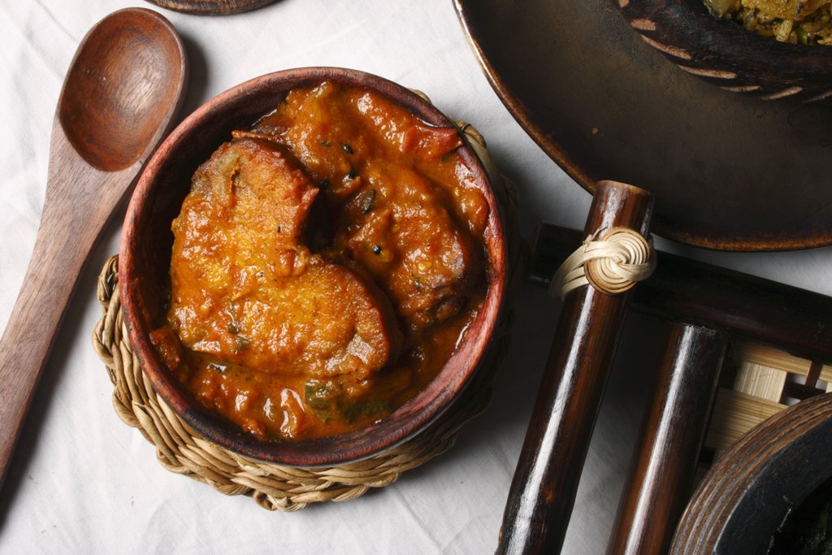

Masor tenga--fish cooked with dried mangosteen

***Masor Tenga***  
Great for summer, this dish is made of fish and slices of dried mangosteen. In the absence of dried mangosteen, the dish can also be made with Kazi nimbu (a family of kaffir lime). This dish is light, perfect for summer time and a favourite among all Assamese communities.

**Duck with Kumura (white gourd)**  
Locally called "*haa*", duck is one of the most popular meats consumed by Assamese folks. White gourd is the choice ingredient because its natural aroma complements the duck. This dish is usually heavily spiced, but delicious nonetheless. This is a must-have.

Photo Credit: Shutterstock

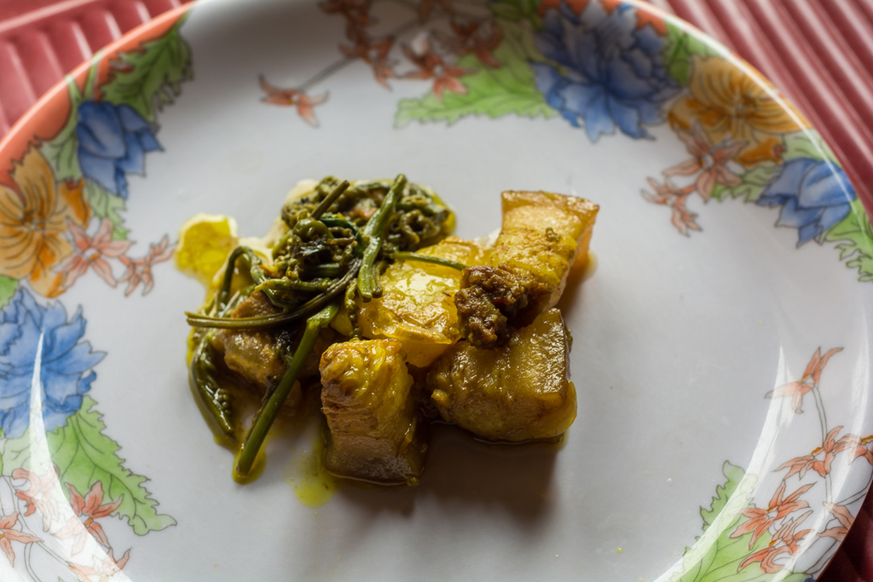

Dhekia xaak or fiddlehead fern cooked with pork, an Assamese delicacy

***Dhekia Xaak***  
This is fiddlehead fern. A vegetable commonly eaten in the hilly regions of India. *Dhekia Xaak* (pronounced as haak) is a sign of spring's arrival. The Assamese folks love their *dhekia*, they like to cook it with tomatoes, dried shrimps, dried mangosteen or just a simple stir fry!

***Kol-phool* with Duck/Chicken/Fish**  
A personal favourite, banana flower or banana heart is a healthy food. Loaded with nutritional goodness, banana flower is also one of the super foods. In Assam, it is eaten mostly with finely chopped duck, chicken meat or fish. Banana flower is full of fibres, antioxidants, light on the stomach and is delicious!

Photo Credit: Shutterstock

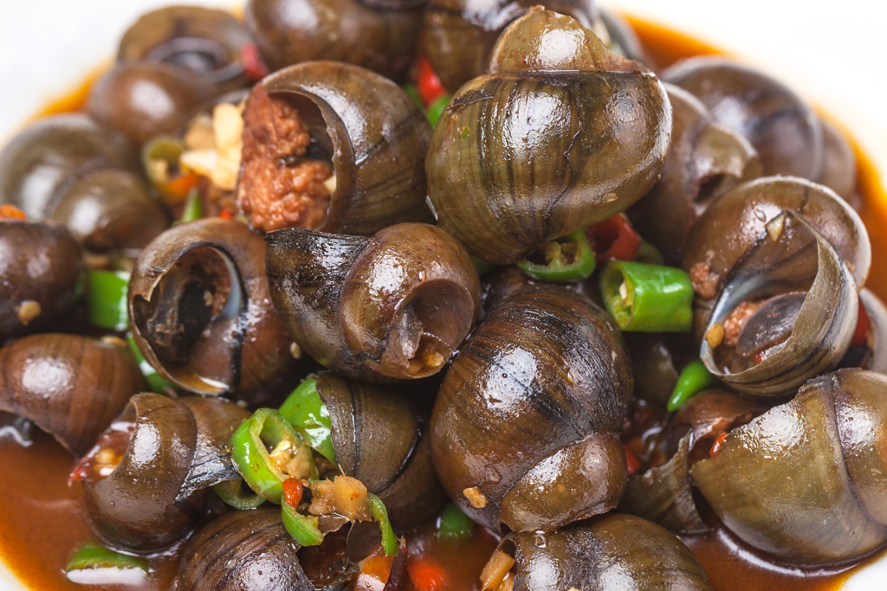

A dish of pani hamuk or river snails

***Pani Hamuk***  
For the uninitiated ones, this dish would be something of a challenge. *Pani hamuk*, translated as water snails, when sourced from paddy field or clean flowing river/streams, taste great. A bit of a challenge because one needs to suck the meat out of the shell. Water snails cooked with pumpkin or potatoes (with pork and fermented beans in Nagaland) are as exotic as they come.

Photo Credit: Shutterstock

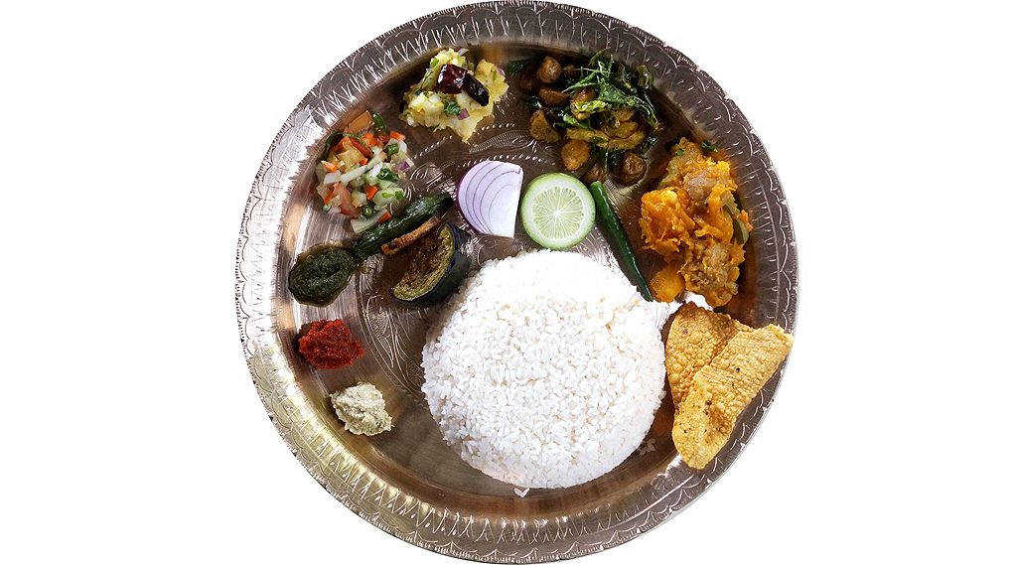

Assamese thali

**Alu/Bengena *Pitika***  
This is one of the most popular side-dishes you'd find in an Assamese thali. Boiled mashed potatoes or roasted and mashed eggplant, mixed with raw mustard oil, finely chopped green chilies and onions—this dish is simple and a big hit at the same time.

Photo Credit: Shutterstock

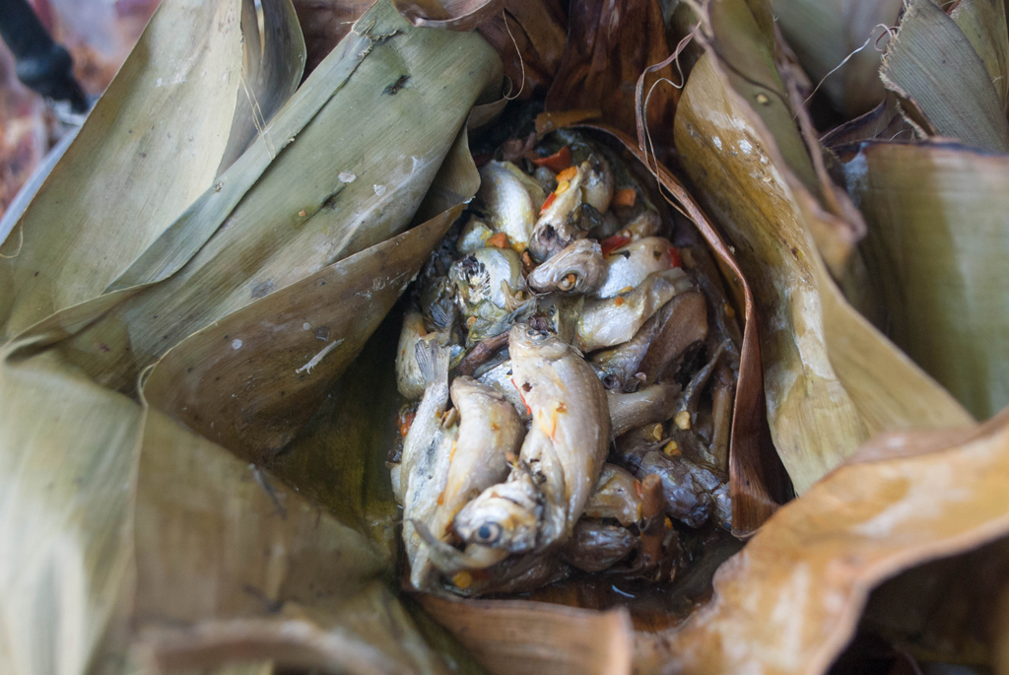

Fish steamed in banana leaf

**Fish Cooked in Banana Leaf**  
This is a steamed dish. Tiny river fishes wrapped and steamed in banana leaf, and later garnished with chopped onion, coriander and fresh green chilies. This is one of the traditional Assamese way to prepare fish item.

***Doi-Chira***  
This is mostly eaten during Bihu but one can eat this daily for breakfast too. Moist flattened rice mixed with curd, cream and jaggery is a local favourite. This is not a dessert, though it may sound like one. For the locals, *doi-chira* is an important traditional dish.

***Pitha***  
Just like the aforementioned *doi-chira, pitha* occurs mostly during Bihu. *Pitha* is equivalent to other Indian dishes but so different and unique. Made either fried, toasted or just hand rolled, these sweet and savoury dishes are an essential part of Assamese tradition and culture.

Bihu Bihu marks the season of change and it is the state festival of Assam. Bihu is celebrated three times a year and has three different names namely Bhogali Bihu or Magh Bihu (in January) , Bohag Bihu or Rongali Bihu in April and Konglai bihu or Kati Bihu in December. Pic credit: Wiki Commons Kamakhya A visit to Guwahati is incomplete without visiting the Kamakhya temple, one of the oldest among the 51 shakti peeths in the country and a temple dedicated to Goddess Kamakhya ( another form of Goddess Kali). Ambubachi Mela, in June, every year, is one of the festivals here that attracts devotees from across the country. Pic credit: Wiki Commons One Horned Rhinoceros The famous one-horned rhino of Assam which is an endangered animal is unique to Assam and attracts tourists from across the world. Visit the world famous Kaziranga wildlife sanctuary to get a glimpse of these animals. Here is how to reach Kaziranga. Pic Credit: Wiki Commons Tea Gardens For the average Assamese, life is unimaginable without a piping hot cup of tea. A cup of tea is welcome anytime during the day. The tea gardens of Assam have been detailed and praised in countless books and movies.Found in upper Assam, definitely try staying on or near a tea estate when you visit Assam. Pic Credit: Wiki Commons Majuli The heart of Neo-Vaishnavite culture in Northeast, one of the largest river islands in Asia, Majuli is home to vaishnavite institutions known as Satras which propagate the teachings of the 15th century Vaishnavite saint Srimanta Sankardeva. Brahmaputra The only male river of India, the Brahmaputra originates in Tibet and enters India from Arunachal Pradesh before entering Assam. Bhoot Jolokia One of the hottest chillis in the world, the Bhoot Jolokia literally translating to Ghost Chilli is also known as red naga chilli. It is cultivated in Assam, Nagaland and Manipur. In 2007, Guinness Book of World Records certified it as the world's hottest chilli, aposiion which has since then gone to the Carolina Reaper. Assam Silk Assam is also famous for its varieties of indigenous silk known as eri and muga. The dresses woven out of these silks known as mekhela sador are part of the traditional attire of the state. Ahom Kings The longest continously ruling dynasty of India which ruled for nearly 600 years, the Ahoms dynasty was established by Sukaphaa, a Shan prince from present day Mynmar and China. The rule of this dynasty ended in 1826 with the Burmese invasion of Assam which forced the Ahom king to seek British help. Subsequently it led to the British annnexation of Assam. The capital of the mighty Ahom kings, Sivasagar, has relics strewn around it. It could do well to be developed as a proper tourism destination.

Read more at: <https://www.nativeplanet.com/travel-guide/10-things-assam-is-famous-for-000495-pg10.html>

### **1. Tea Leaves**

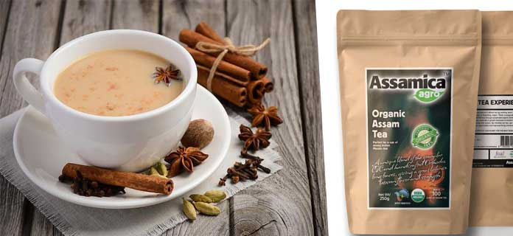

Assam Tea is well-known in India and across the whole world. Assam happens to be one of the few places in the world where tea is planted in the plains. The Assam tea has a very nice smell, as is nice in taste too. There are many local markets in Assam, where one can find tea leaves. Many of the tourists coming from outside definitely take these souvenirs with them.

Advertisement

Assam is the largest tea producing state in India. Assam Tea is very much popular in India and across the world. The Assam tea has a unique smell, as is amazing in taste too. There are many local markets in Assam, where one can find tea leaves. Assam is one of the few places on earth where tea is grown in plains and it is the single largest bordering tea growing region in the world which includes the northern Brahmaputra valley, the Cachar hills, the southern Barak valley and Karbi.

The tea grown in Assam has a deep fragrance, rich colour as well as a malty taste. You can also visit India’s largest tea research centre located at Tocklai in Jorhat. Most importantly as you leave Guwahati, you can collect a pack of CTC Assam tea. CTC tea leaves are freshly packed and it comes in many irresistible and fresh flavor packs.

### **2. Assam Silk**

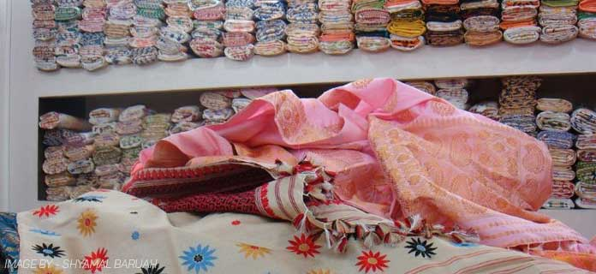

Although there are several states in India where you can shop for silk products, Assam has its own share of silk heaven.The state produces one of the finest qualities of silk. Silk found here is relatively expensive due to it better quality.

The three main types of silk here are Muga, Pat and Eri silk. Muga silk is widely used in Assam and many of the traditional dresses are made out of it.

Muga silk is used to make traditional Assamese dress for women (mekhela chador) and other garments like sarees, kurtas etc.Pat silk are smoother than Muga and they are also used for making clothing, perhaps Pat silk will make a fine summer wear. Eri silk, on the other hand, is a bit coarse and unrefined; hence, they are mostly used to make shawls.

### **3. Handicraft**

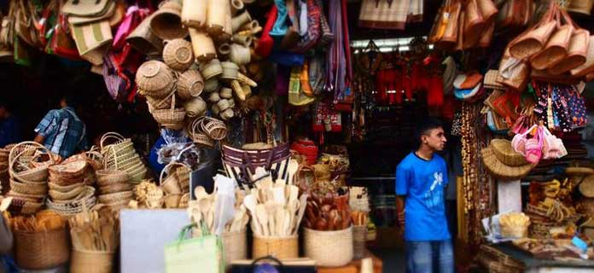

Guwahati is the primary hub of all the Northeastern states, and being home to a large number of tribes and sub-tribes you will find vivid handmade crafts here. Assam has various kinds of handicraft products. The state is full of wood, bamboo and various tribes who make these. You can find a variety of handicraft items right here. Handicrafts items are one of the most famous things to buy in Guwahati.

* Handloom
* Jewelry
* Bamboo and Cane products
* Brass and Bell metal crafts
* Pottery
* Woodcraft
* Masks
* Terracotta
* Traditional Paintings
* Toys

Apart from the wood handicraft products, the metal-craft items and pottery are also very popular.

### **4. Pickles**

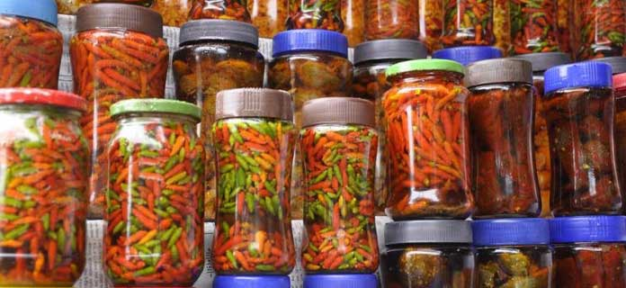

The pickles of Assam and other North East states have greate taste. Most of these are home-made and tangy and spicy in taste. You can find many variants of these pickles. While buying the pickles you have to choose an ovariant amongthe various options.

Pickles of Assam are beautifully prepared, they are homely, organic. These pickles are made from local herbs and you won’t find such varity and taste anywhere. These pickles are infused with dried fish, bamboo shoots, pork, beef, sesame, chicken, you can pick whatever you like. In the process of making, these pickles are dipped in mustard oil, plain salt or vinegar and then stored or soaked them in the sun. When you are in Guwahati, a packed of a pickle is a must buy product.

### **5. Singing Bowls**

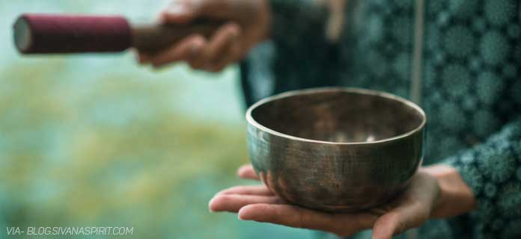

Singing bowl is another popular choice of tourist for its uniqueness. Some of these bowls are designed with mantras engraved on them and it is believed that it brings peace and happiness in life. Another amazing thing about these bowls are that you will hear a calming sound while you rotate the handle around the bowl. The price of these bowls varies according to size. Tourists love this singing bowl and you can also have this for your collection.

### **6. Hand Made Toys**

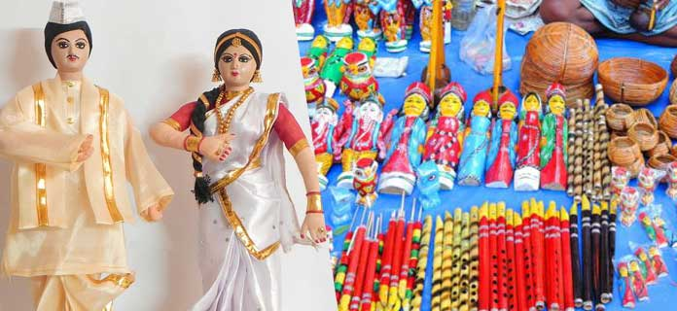

Toys in Assam are made in the most ethnic and the traditional way. Figures of Gods and Goddesses, animals and many mythological figures are crafted by the local craftsmen of the state. The toys of Assam have been broadly classified under four categories, they are: clay toys, pith, wooden and bamboo toys, and cloth and cloth-and-mud toys.

Assam’s Goalpara district is famous for the cork or pith toys. In this instance, mostly figures of birds, animal figures and forms of gods and goddesses are used for the output. Toys are also carved in wood. Wood and bamboo have been used for toy making for a long time. The toys made of cloth, or a mixture of cloth and mud, have also become a part of the Assamese toy making culture.

### **7. Jaapi & Wooden Rhino Statue**

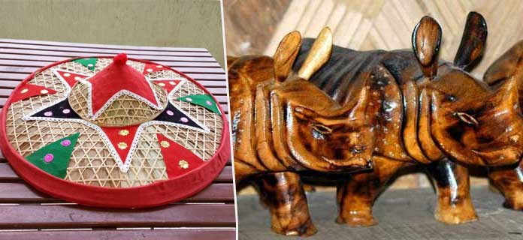

The jaapi or japi is a traditional funnel-shaped hat of Assam. Jaapi is considered to be a symbol of Assamese culture and worn in a style of Bihu dance. Jaapi offered as a sign of respect in rituals, and positioned as a decorative item around the house, especially near the front door as a welcome sign. It is made from strongly woven bamboo and/or cane and tokou paat a large, palm leaf.

Again, as we know that Assam is known for its one-horned rhinos, you can find handmade wooden rhinos as a memento. These are ideal for home/office decoration, gift, and felicitation. These wooden statues of a Rhino come in various sizes. A Rhino statue is a must carry souvenir from Assam.

### **8. Assamese Traditional Jewelry**

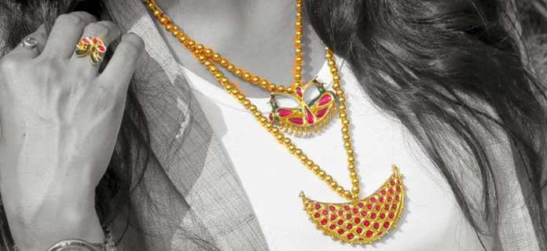

Assam has a rich tradition of manufacturing gold jewellery dates back to several centuries. These jeweleries are typically hand-made, and the designs mostly depict floral and fauna treasures of the region.

The designs of Assamese traditional jeweleries are simple, beautiful and they never go out of fashion. Many of the designs are exclusive to this state only.These are decorated with vibrant red gemstone, ruby or mina. Black, red and green colors on are most favorites among the buyers. Each piece has a name which describes and indicates the shape and decorative work done on it.

### **9. Phulam Gamusa (Towel)**

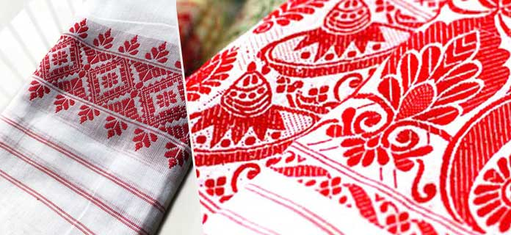

The Gamusa/Gamosa/Gamocha is an article of great significance for the people of Assam and the very symbol of Assamese culture. A Gamusa is a white rectangular piece of cloth with primarily a red border on three sides and red woven motifs on the fourth. In addition to red, other colors are also used.

Gamusa is one of the most easily recognizable cultural symbols of Assam. It is an integral part of almost all social/cultural ceremonies. Gamusa is one of the most famous things to buy in Guwahati.

**READ**: [5 Facts Nobody Will Tell You About Gamusa](https://www.magicalassam.com/2016/04/gamosa-gamocha-assam.html)

### **10. Traditional Mask**

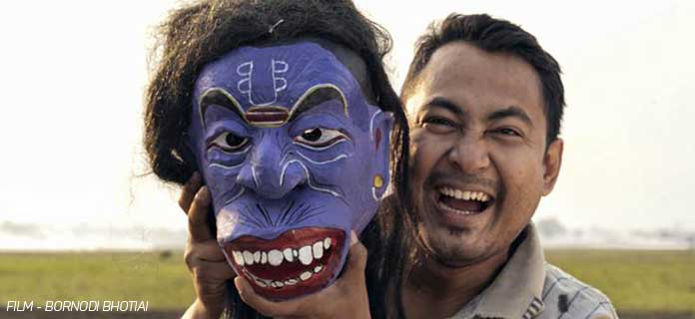

Masks, also known as mukhas, are the base of the Assamese culture and tradition. They are worn mostly during theatres and bhaonas. Bhaona is a traditional form of entertainment, always with religious messages, prevalent. Since ages, these masks have been the focus of each and every cultural event of Assam. These traditional masks are created from a variety of materials, ranging from terracotta and bamboo to wood, pith and metals.